- After registering a new patient from “IPD Admission” page – it should land back to the “IPD admission page” – currently it lands on the patient profile page
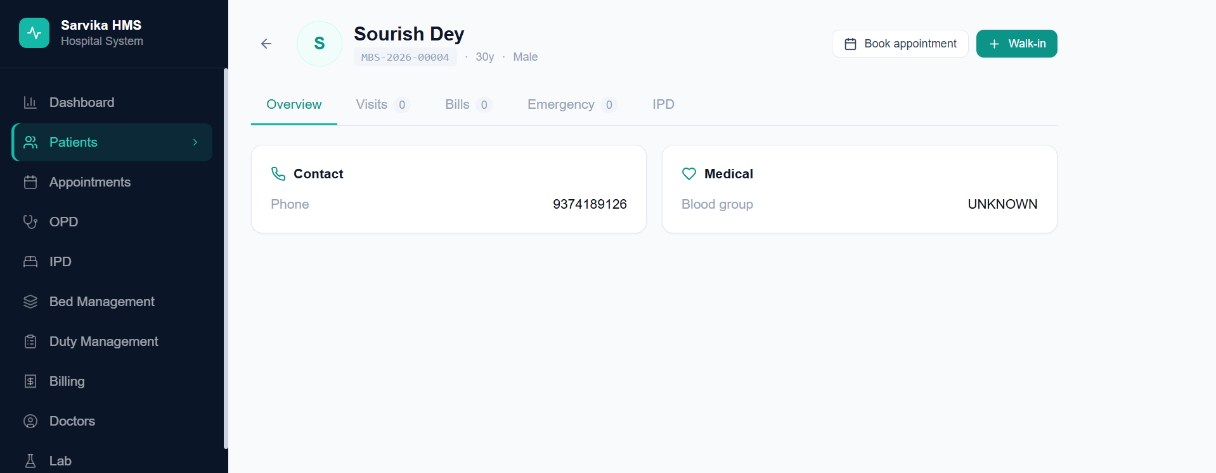
- Attending Doctors list not working – it should be the List of IPD doctors
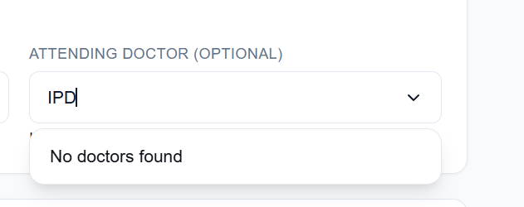
- Bedgrid numbers not updating – please refer to the below screenshot – it should have shown 1 available bed, total beds: 2 and the other numbers should be correct as well
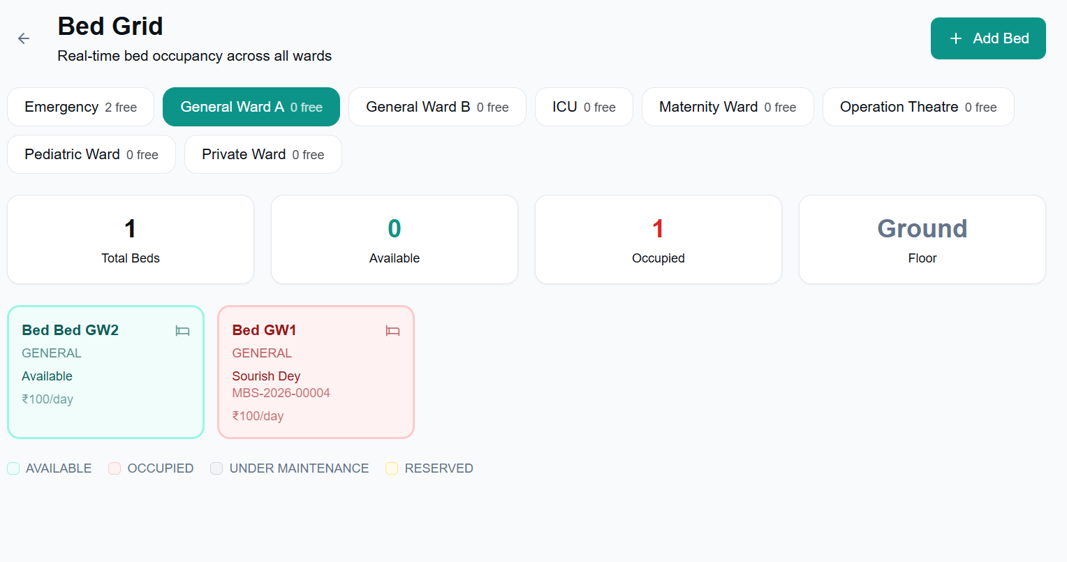
- While adding staffs through admin -> settings page. There is no option to add IPD nurse and nurse superintendent
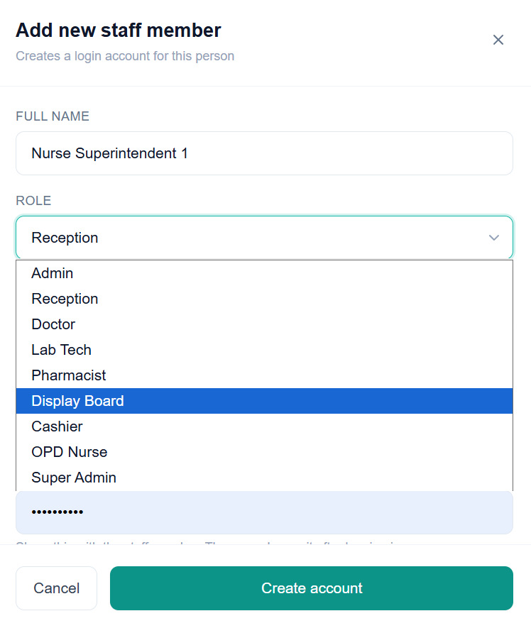
- Bed accruing charge – calculation error. For example the below screenshot – the patient got admitted today and the bed charge is set as “100” but it is showing – charged: 100; accruing: 0.37; total outstanding: 100.37 – but ideally the outstanding balance should have been 0.37 as well (because the bed charge is 100 per day and the patient got admitted today). Please note everything else in the billing should be same
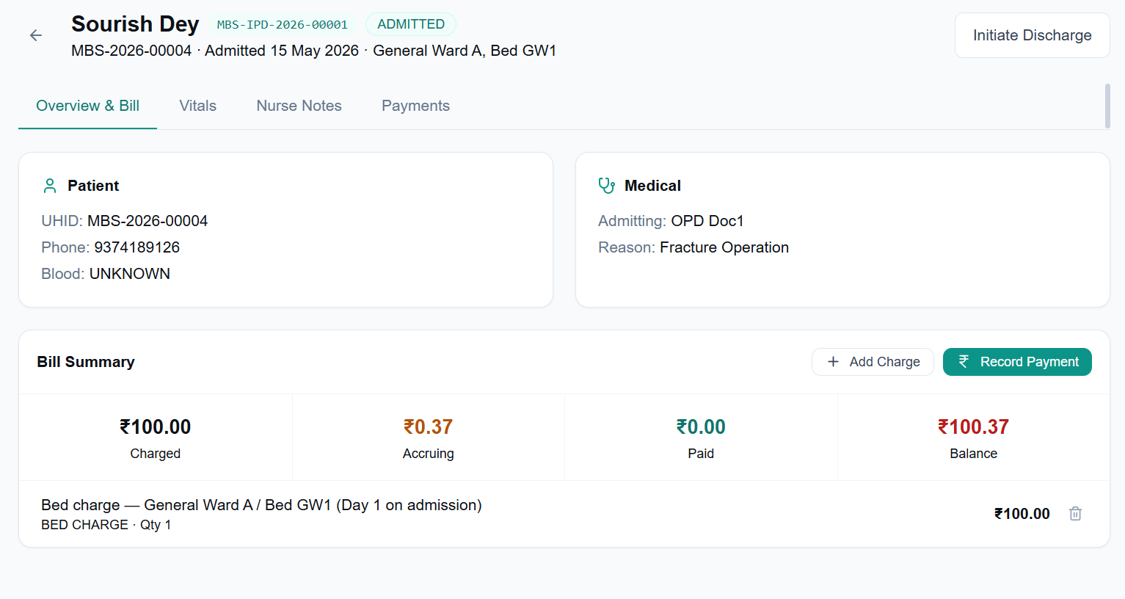
- Cashier Screen – in the billing page should be able to see ongoing IPD bills as well with an option to partly settle the ongoing bill as was described earlier in the workflow
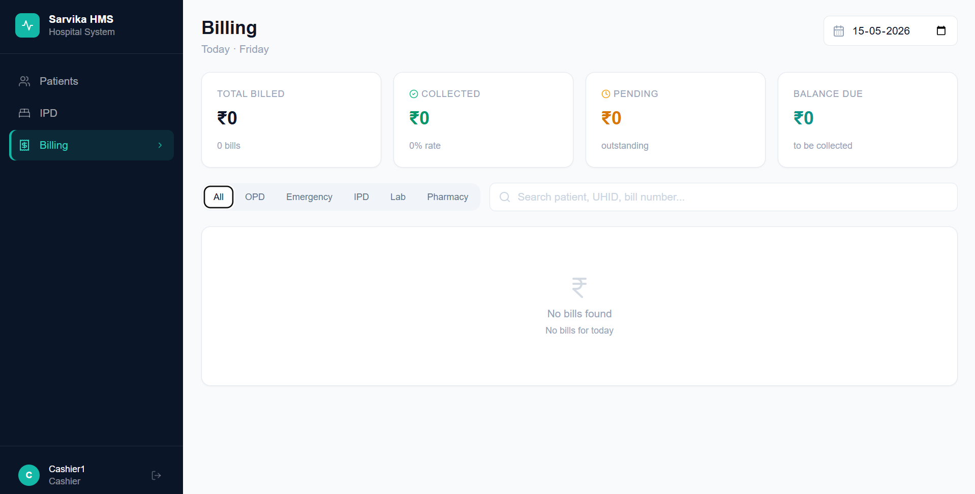
- Cashier screen – IPD failed to load page when clicked on view against a patient bill
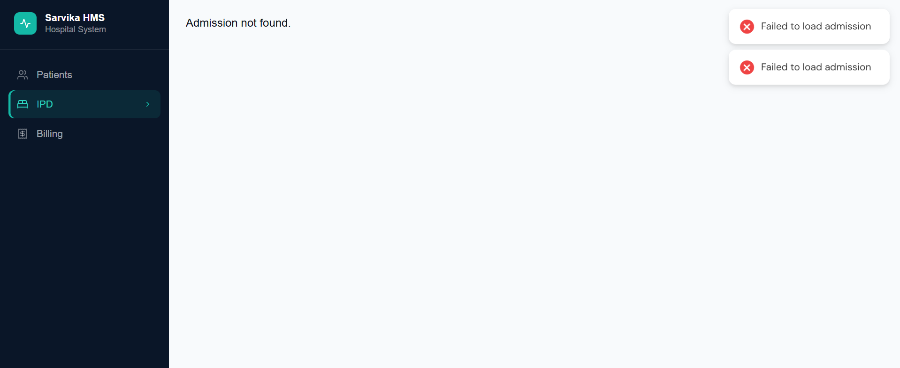
- Receptionist screen should not have option of “collect payment now” and the entire section should not be there while generating a bill
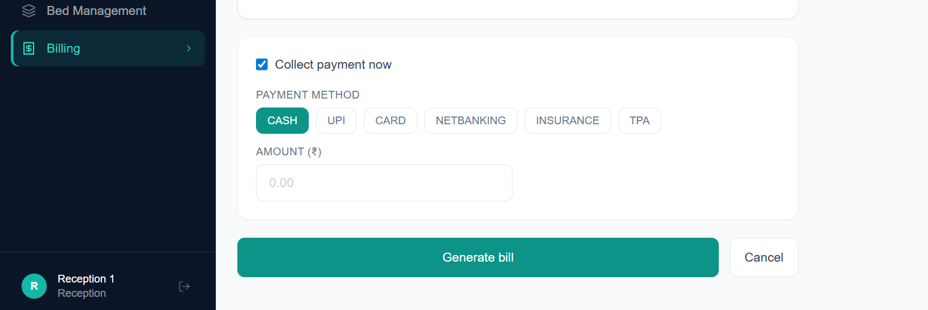
- Generate bill page in the bill items doctor consultation charge for IPD not getting auto-filled
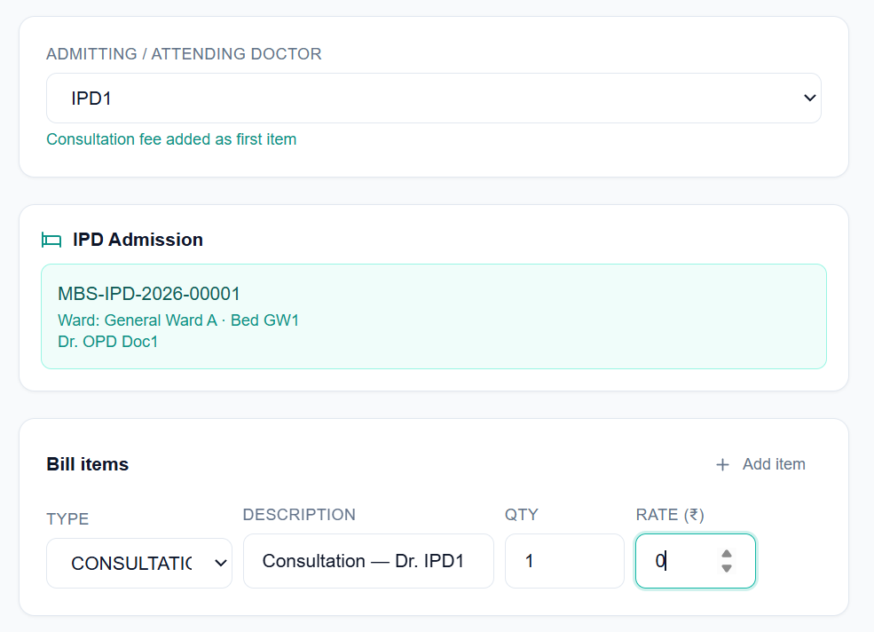
- While generating bill page -> “Consumables” bill item to be a drop-down of prefilled inventory items under consumables category
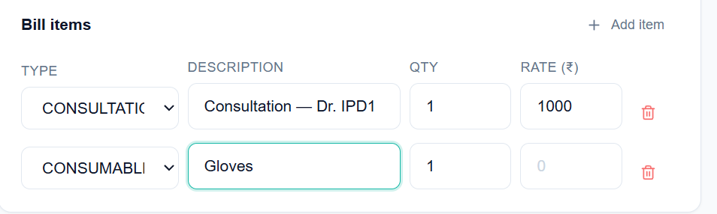
- After adding bill to an existing admission for a patient admitted in IPD – in the IPD page – patient overview and bill page has not updated it. I think the bill is not getting connected. For the below example – I have just added two more items to the existing bill as you can see in the below screenshots (Although in the billing page – both the bills got added into a single bill – but somehow the IPD page patient overview and bill is not reflecting the same)
